Tatevik Azoyan
August 6, 2024

Executive Summary

Sign-up flow is the first interaction users have with the product. A smooth sign-up experience can create a positive first impression, encouraging more users to complete registration. Good sign up flow sets the tone for overall user experience, and may help users to understand the value of your product, increasing the likelihood of user engagement and retention.
Feature Name | Sign up/Sign in flow redesign
Product Area | Main website
User Persona/ Story | All Haibrid users.  As a user, I want an easy and familiar way to create an account/log in.
Description | Overview  Convenient sign-up flow will shape user perceptions, and set the foundation for ongoing user engagement and satisfaction.  Key Features  - Sign in with google  - Sign up with email/password  - Adding personal details  - Creating a workspace and Inviting Friends  - Prompt to download the extension  - Login page redesign
User Problem | - Complex or too lengthy sign-up/onboarding flows  - Confusing navigation and lack of instructions  - Being forced to have access to email to validate each time signing in  - Privacy concerns/lack of transparency  - Limited options of sign up
Value Proposition | A well-designed sign-up flow ensures effortless user onboarding, fostering positive first impressions and higher conversion rates.
Objectives | - Increased User Acquisition: Encouraging more users to complete registration  - Enhanced User Engagement: Creating positive perception of the product from the beginning.  - Increased Conversion Rates: reduce abandonment rate by creating smooth log in experience for existing users
Assumptions | - Users seek efficiency  - Some users prefer instant sign in without creating an account (Continue with google, etc.)  - Users prefer simplicity and familiarity in all flows  - Users may have limited patience for complex customized flows  - (Capturing users’ work emails would be helpful to identify companies/industries of our users
MVP | - Redesigned sign up and log in windows  - Prompting to download the extension  - Add details during sign up for personalized experience (Purpose of using Haibrid and Role)
Out of Scope | - Additional details during sign up for personalized experience ( Team Size, Company Name, etc.)  - Sign in with Enterprise SSO/Slack/Facebook/Apple  - Billing  - Ask where data should be hosted (US or Europe) (Do we even need it?)  - Have account settings and change password flow  Workspaces -- Adding a workspace and Inviting Collaborators  - Uploading a workspace logo  Selection of any of the roles should open the page to create a workspace, consisting of:  - A free-form input to type in a Workspace Name (required field)  - Texts, encouraging to create a workspace and add collaborators, such as ​​“Set up a workspace to invite your team and start collaborating immediately and bring your ideas to life together.” or “Organize your work with a dedicated workspace.” (Other suggestions are welcome)  - question with single choice Yes/No answer:  Do you plan to collaborate with your team on our platform?  - Yes (opens an input for email invitation with permissions defined (Editor or viewer, once input is done with at least one email an input for creating a workspace should be rolled out, after a name of a workspace is typed a “Get started” button activates”. )  - No (a “Continue” button activates)  Selection of any of the roles should open the page to create a workspace, consisting of:  - A free-form input to type in a Workspace Name (required field)  - Texts, encouraging to create a workspace and add collaborators, such as ​​“Set up a workspace to invite your team and start collaborating immediately and bring your ideas to life together.” or “Organize your work with a dedicated workspace.” (Other suggestions are welcome)  - question with single choice Yes/No answer:  Do you plan to collaborate with your team on our platform?  - Yes (opens an input for email invitation with permissions defined (Editor or viewer, once input is done with at least one email an input for creating a workspace should be rolled out, after a name of a workspace is typed a “Get started” button activates”. )  - No (a “Continue” button activates)
KPIs | - % of users redirected from landing page eventually completing sign-up  - % of users downloading the extension immediately upon sign-up
Requirements | Sign Up/In Flow Requirements  2 ways to sign up/in:  - Google sign up/in  - Email sign up/in  SIGN UP  “Continue with Google” button  - requires Google standart authentication flow  - allow cookies  - select email  - security confirmation  or  Email  - requires email input and password set up  - set email validation (e.g. exapmle@domain.ww)  - set a minimum 6 character limit for password.  - email verification input ( 6 digit code is sent to email for confirmation)  USER ONBOARDING STEP 1  Once either of the sign up methods is conducted, user onboarding should consist of:  - Full Name (one line input)  - What will you be using Haibrid for? (should open 3 single choice options to choose from: Work/Personal/Education)  We should either have “Back” buttons throughout the onboarding flow or show all next steps (dropdowns) in the same page so that users have the ability to change their selection.  - Work (if chosen should suggest a dropdown input with the following options to answer the following question:)  What team are you on?  - Research  - Media  - Marketing  - Recruitment  - Sales  - Other  - Personal (if chosen should suggest a dropdown input with the following options to answer the following question:)  What are you primarily planning to work on?  - Inspo collection  - Personal Project  - Bookmarking  - Collection of good reads  - other  - (please add your options team jan)  - Education(if chosen should suggest a dropdown input with the following options to answer the following question:)  - What is your role in education?  - Student  - Professor  - Administrator  Other mandatory attributes on the first (Sign up) page to consider:  - “By Signing Up you agree to our Privacy Policy and Terms of Use”.  - Already have an account? Log in. We set Sign Up as a default option for users as most of them will be new to our platform, plus “Google sign up” serves as a log in as well.  USER ONBOARDING STEP 2  Extension Download Prompt Page  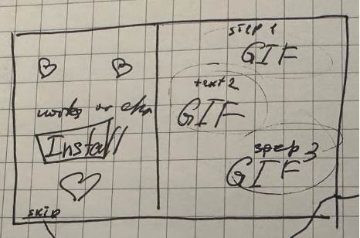  TBD – Can/Should we implement animations at this stage? GIFs instead of pictures and some engaging animation on the left side)  On the left section:  · “Introducing Haibrid Extension”  · “Increase your productivity by quickly saving and organizing web sources using our extension”  text (Can add more descriptive, instruction-like text if UI wouldn’t be overloaded)  · Works on Chrome, Microsoft Edge, (what else?) I suggest listing instead of writing Chromium as some users might get confused  · “Install Our Extension– It’s Free” button  · Skip – Small clickable text (underlined, in a faded color)  On the right section:  Step 1. Save web pages and even highlighted texts  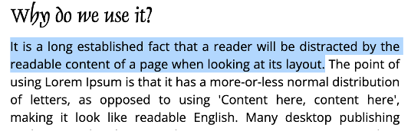  Step 2. Add Notes and Tags  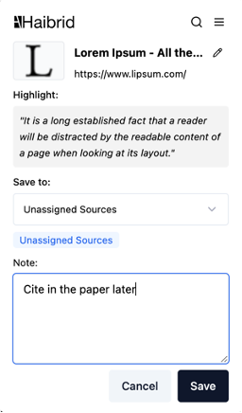  Step 3. Save to well-organized projects  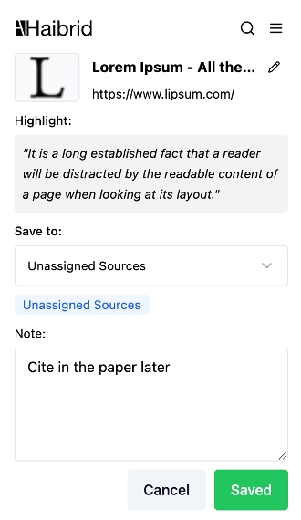  1. If user clicks on “Install”, user should get redirected to Haibrid Chrome store page opened in a new tab. Once “Install” fires, “Get Started” button should activate, navigating the user to his main dashboard. (Download extension button should be visible at this point if the extension is not installed yet).  2. If the user clicks on skip, he/she should be redirected to the main page, the “Download Extension” button should be visible, and highlighted by a tooltip “Don’t miss out!” Full experience is just one click away”. Users should periodically see this tooltip if the extension is not installed (i.e. once in every 3 days). “Download Extension” button should remain visible and static on all Haibrid website pages until the extension is downloaded.  We should add short tooltips/instructions once the extension is downloaded  Sign In Page Requirements  - Continue with Google  - Email (Required) - Should display standard validations if format is incorrect should indicate “Please enter a valid email address” or after submission if there is no account with such email “Incorrect Email or Password”.  - “Password” (Required) - Should display an “Incorrect Email or Password” validation if the wrong password.  - “Forgot password?” button - Should redirect users to another page, where users should see the following components:  - Already have an account? Sign in (this option should remain visible throughout all steps)  - Prompt to provide an email to send instructions (for example, “Enter your email, and we’ll send you instructions on how to reset your password)  - Email free form input (Display incorrect email validation)  - “Send email” button - Confirmation message should appear after email is sent (for example, “Instructions are sent to your email. If you don't receive it please try again and make sure you enter the right email.”)  Users should receive an Email containing:  - A standardized text (Podcastle example, “Hey, we’ve received a request to reset your Podcastle account password. To reset your password, click the button below.  - “Reset Password” button - clicking on the button should redirect users to a new page containing the following fields:  - New Password - free form field (minimum 6 character limit for password)  - Confirm Password - free form field (Add “Passwords don’t match” validation)  - “Save” button - After clicking on it, users should see a “Password changed successfully” validation, and button/prompt to get redirected to “Sign in” window  Reset password link should not get expired after some time and can be used multiple times (like it is done in podcastle, TBC)  - “Log In”/”Continue” button.  - Don’t have an account yet? Sign Up
Competitor /Market Research | Market Overview  Competitive Analysis  Market Trends  Competitors’ designs examples for inspiration:  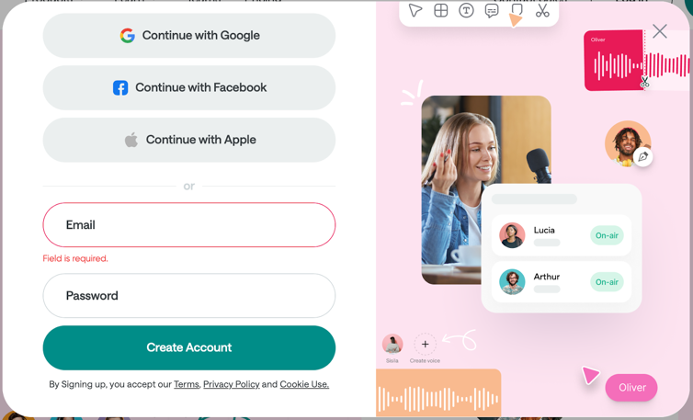  Podcastle (liked using colored button for “Create Account” – Call to action)  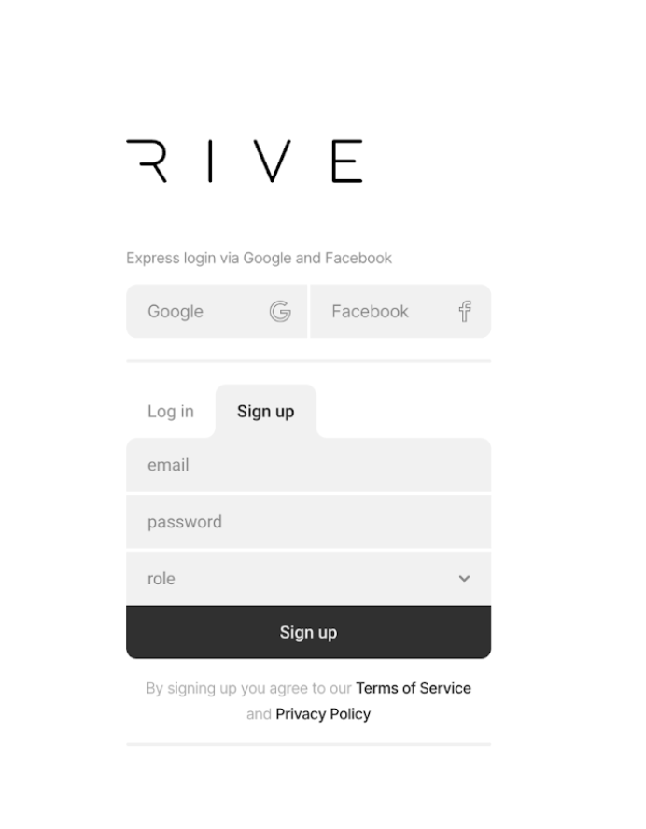  Rive (liked their sign up/log in quick switching, close to Haibrid aesthetics)  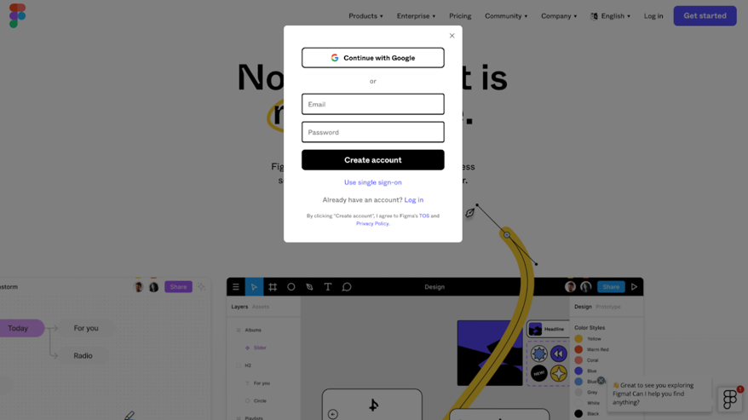  Figma (using pop up instead of redirecting to a separate page, can implement in a similar way when trying to log in/sign up from the landing page.  x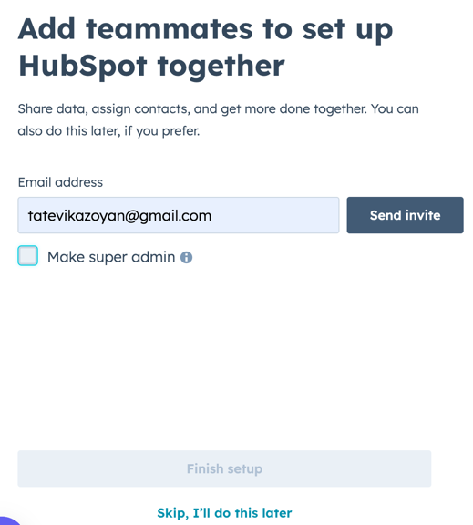  Hubspot example of inviting teammates  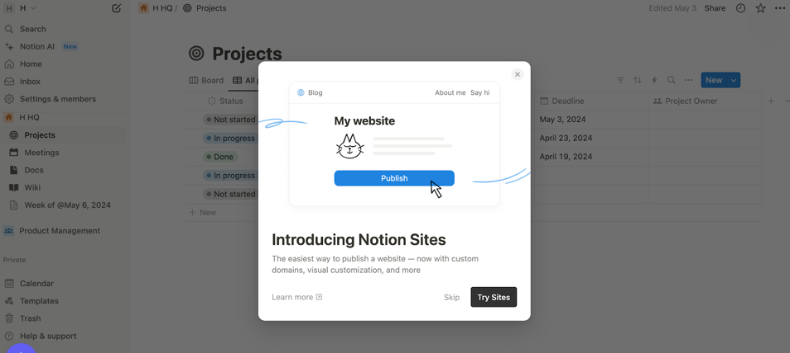  Notion example of introducing new feature with redirecting, can implement to push to download the extension  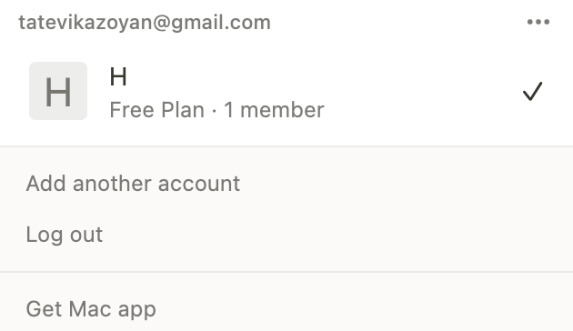  Notion example of encouraging to download the app from the user settings
High-level Mock Ups |   Extension Download Prompt page

